Submitting Assignments in Blackboard

Blackboard’s assignment tool allows instructors to assign coursework for you to submit electronically. First, you need to locate the assignment in the appropriate Course Content folder. The assignment icon looks like a sheet of paper. The requirements, instructions, and other important information about the assignment will be displayed under the assignment title.

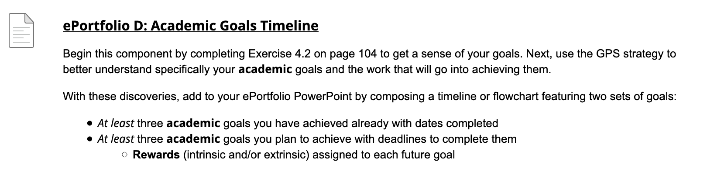

When you are ready to submit your assignment materials, open the assignment by clicking on its title.

You are now in the upload assignment area where you attach and submit your materials. In the first section, you will see the assignment information again, which includes the name, instructions, due date, any attached rubrics and assignment sheets, and points possible.

Important: Once you’ve click on the assignment title and reached this screen, you must submit something. Do not use your browser’s back button to get out of the assignment. Most instructors allow only one attempt per assignment so submitting a blank assignment is something you want to avoid doing.

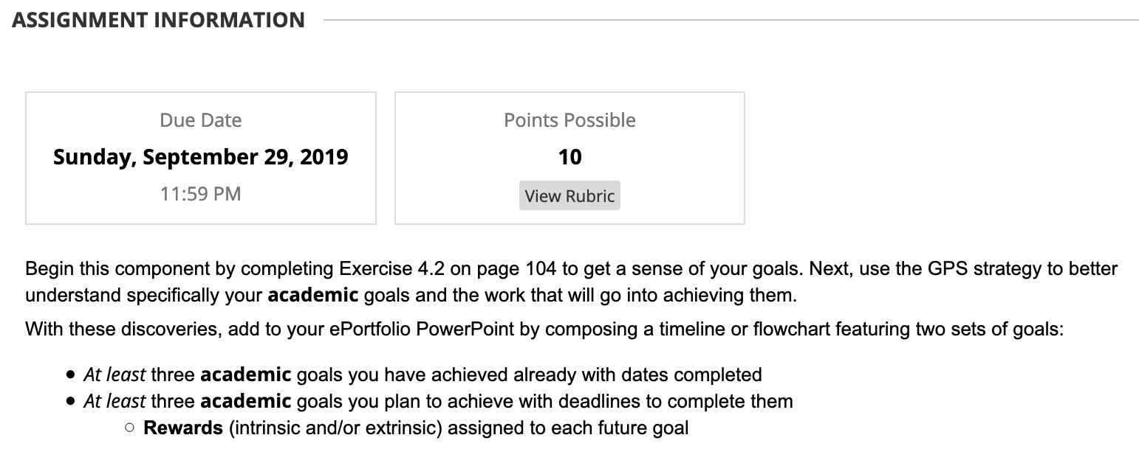

Three Options to Submit Assignments
Blackboard provides three ways for you to give your instructor materials: attach a file from your computer/local files, attach a file from a cloud storage service, or type in a submission box. Double check the assignment instructions, your syllabus, or the course announcements before you type in the submission box. Most instructors prefer or require that you attach a separate file rather than typing in the submission box.

Attach a File Stored on Your Computer
To attach a file from your computer, click the “Browse Local Files” button and locate the file.

Before you attach your file, make sure it is saved in a location where you can find it on your computer and that the file is closed. Select your file and click open.

Note: If your file name has a tilde at the beginning, your instructor will not be able to open it. Cancel the upload, minimize your browser window, and close the file first. Also, your file should not contain any special characters (~ , : ; “ + = % ‘ @ ! ? / { } [ ] \ ).

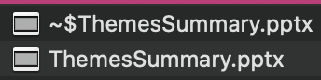

Once you select open, the file will be attached to the assignment. If the attached files line is blank, you have not successfully attached it.

If you need to attach another file, you can add it by clicking the “Browse Local Files” button again and following the previous steps.

If you accidently attached the wrong file, click on the “Do not attach link,” which will prompt you to confirm that you want to delete the file.

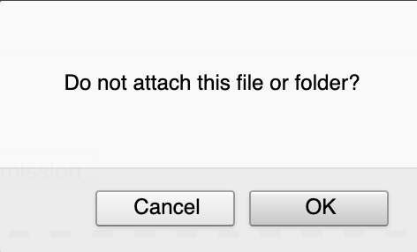

Attach a File Stored in the Cloud
If you created your document and saved it in the cloud (Google Drive, OneDrive, OneDrive for Business, Dropbox, or Box), you may attach your file from your cloud storage area. Instead of clicking the “Browse Local Files” button, click “Browse Cloud Service.”

The first time you submit a file this way, you will need to add your cloud account. Start by clicking on the icon where your document is stored and follow the prompts to sign into your account.

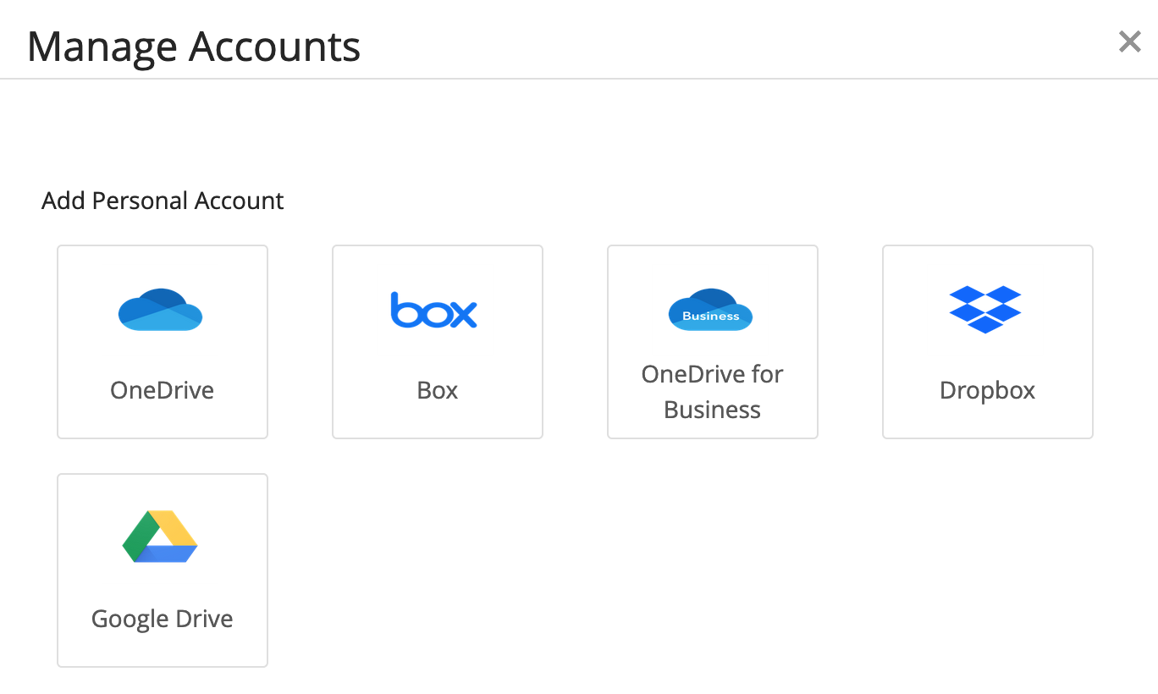

Note: If you are using the Office 365 apps available with your myDMACC account, select OneDrive for Business and sign in with your DMACC username and password.

Once you have signed in, you will see the files stored in your cloud and can double-click the appropriate file or click the file title and then click the Select button to attach.

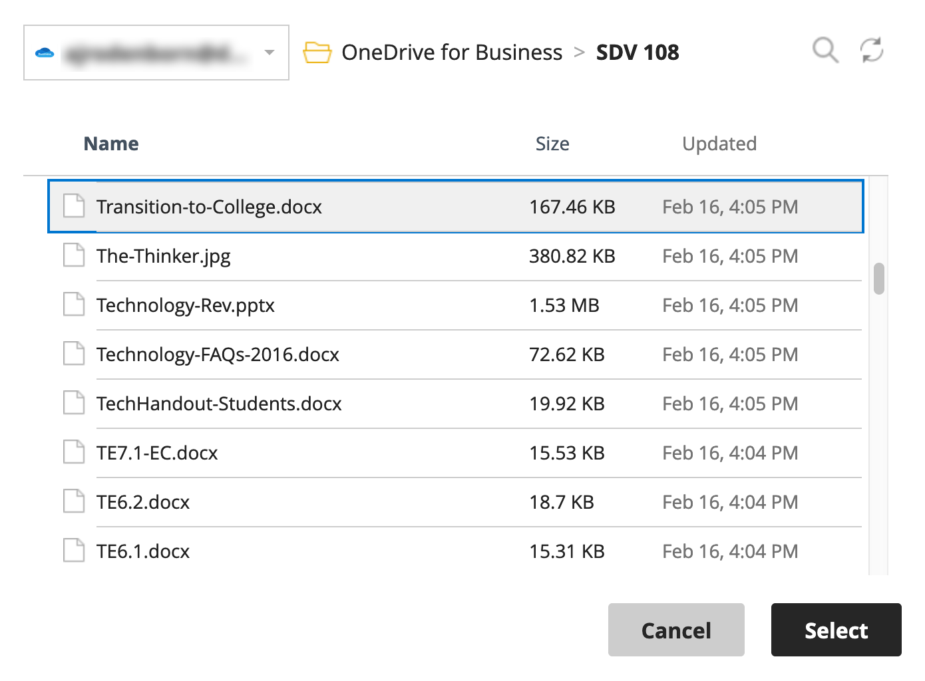

Type Your Submission
If your instructor asks you to type in the submission area, click the “Write Submission” button. This will extend the page with a text editor for you to type in. The text editor has basic commands like Microsoft Office. The button with “ABC” and a checkmark provides spell check for your entry. For ease of reading, do not change the font size, type, or color unless necessary for your submission.

More editing options can be added, such as subscript text, links, tables and other features, by clicking the three dots icon in the content editor toolbar. This will add more buttons.

In the last section, you can add comments for your instructor, but this is not part of your submission.

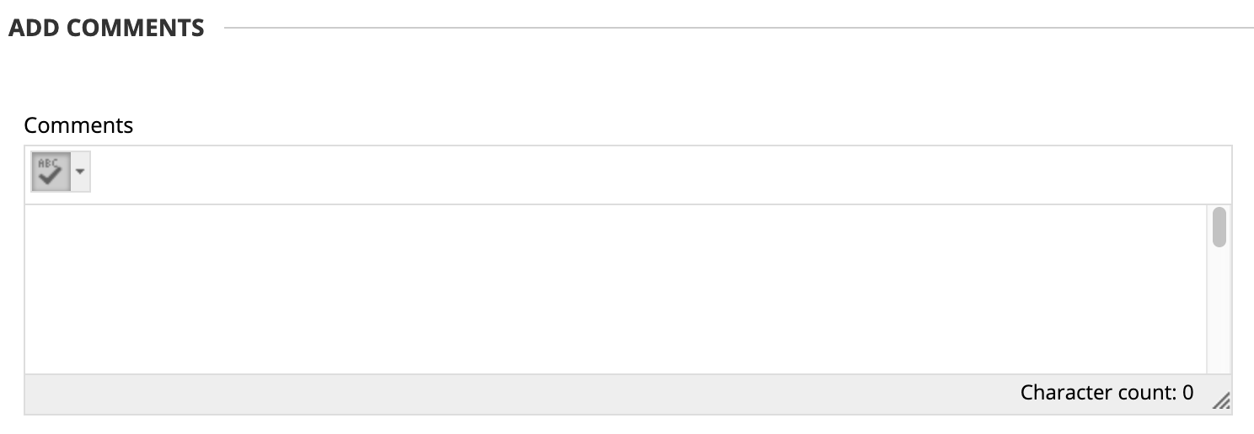

Once you have confirmed that all the files and text you want to submit are attached and included, click the Submit button.

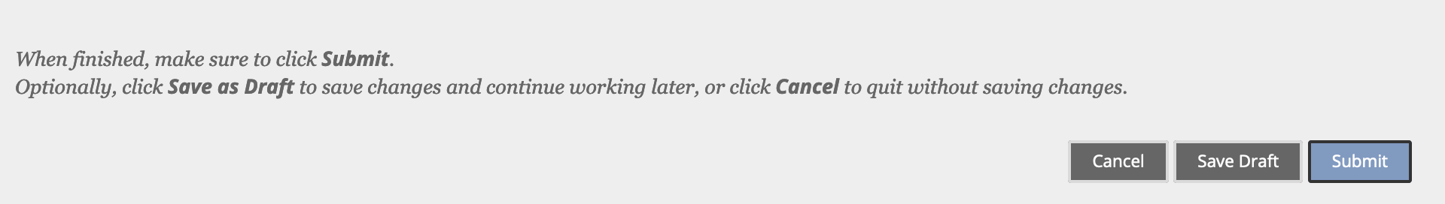

Blackboard will display a receipt showing the date and time you submitted your assignment. Under Submission in the panel on the right, you will also see any attached files or submission text you provided.

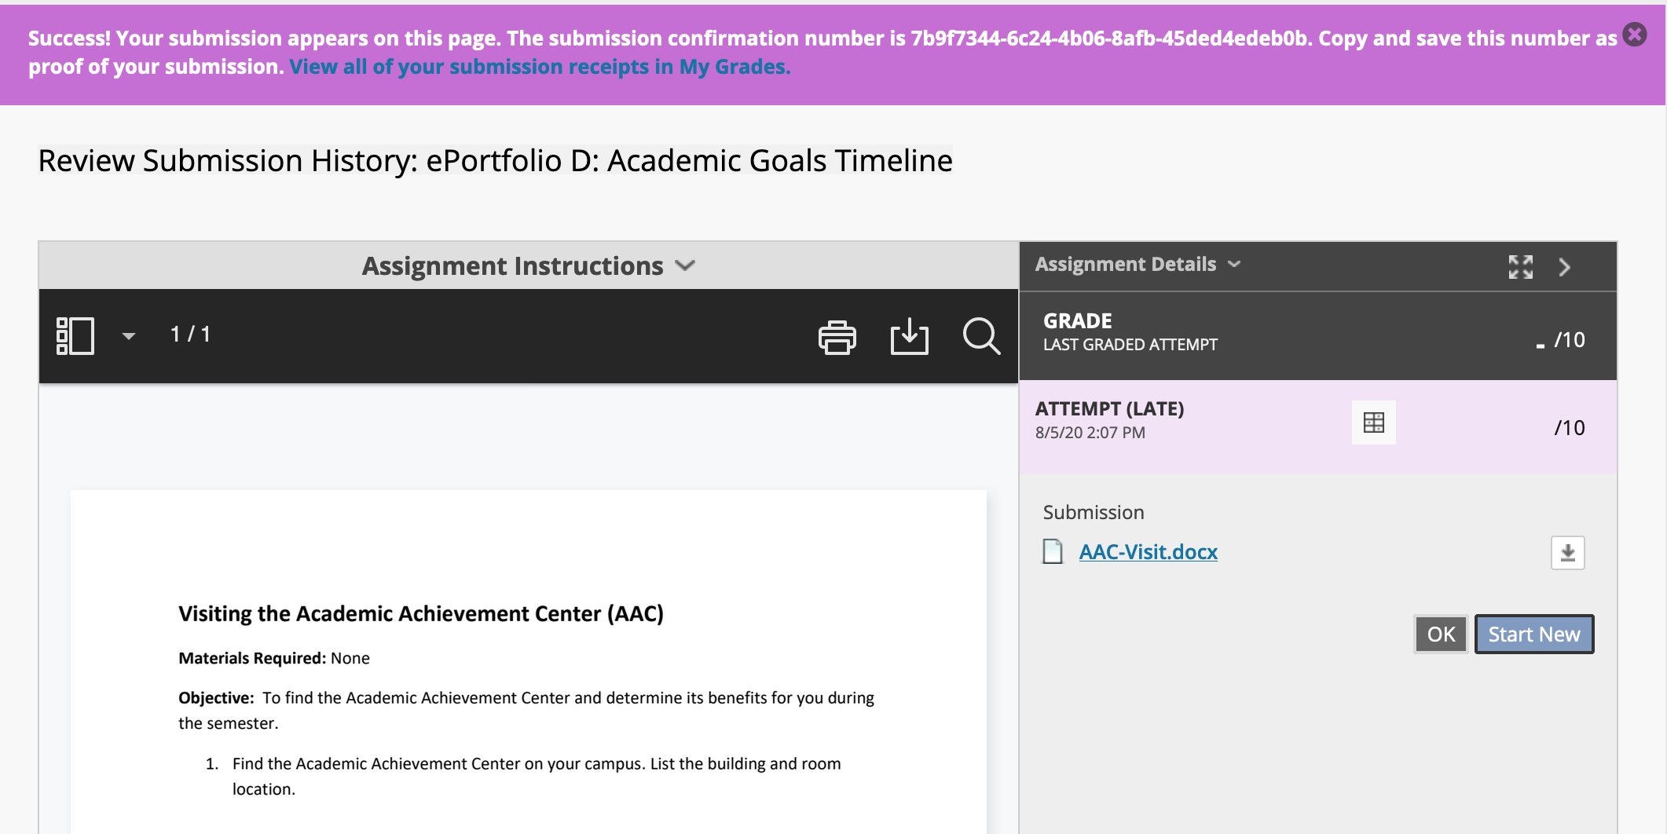

If you navigate to My Grades, you will now see that the assignment has been labeled “Submitted” and includes the date and time stamp. The exclamation point icon indicates your assignment was successfully submitted and is waiting to be graded.

Once your instructor grades the assignment, your score will appear in place of the icon. If your instructor provides comments, you will see a comment bubble next to the score, which you can click to view the feedback. If a rubric was attached to the assignment, you will see a table icon, which you can also click to view. Finally, you can click the assignment title again to view your submission alongside instructor feedback and rubrics as well as any annotations or other inline grading.

Note: Some instructors add annotations within your submitted assignment, which can only be viewed by clicking on the assignment title within My Grades.

